

staff, B. E. R. 《Minimum Wage and Unemployment: Is It Time to Break up with Neoclassical Economics?》 *Berkeley Economic Review*, https://econreview.berkeley.edu/minimum-wage-and-unemployment-is-it-time-to-break-up-with-neoclassical-economics/.

**Do minimum wages impact unemployment? Does the relationship differ by region, group or time?**

Course: ECO220

Course Name: Quantitative Methods in Economics

Professor:

Date:

A minimum wage is the lowest financial compensation that employers can legally pay their employees. The birth of the new minimum wage research (NMWR) can be dated to a conference at Cornell University held in late 1991 (Belman, D., & Wolfson, P. J. (2014). And most countries had introduced minimum wage legislation by the end of 20th century. Issues around who is affected by changes in the minimum wage have been discussed for a long time. Most of the economists concluded that raising the minimum wage would cause negative impact on employment. They have the concern that minimum wage might destroy jobs from the most basic of economic models: supply and demand. If the labour cost arises, employers will probably want less of labours. (“What harm do minimum wages do?”, 2020)

In this paper, we will analyze the dataset which comprises quarterly time series data from the Canadian provinces and territories from Statistic Canada, the Alberta. The dataset contains minimum wage(in CDN $) for the province or country in the quarter; the annual and quarter GDP; the number of labour force over 15 years old and the unemployment rate with different ages and different industries background, etc. By further investigation, we will (1) found out the relationship between the minimum wage and the unemployment rate across different region, groups or time , and (2) what effect would the change in minimum wage make on GDP.

First of all, we check the trend of change for minimum wage across different regions and time. By splitting the dataset according to all the categories of location variable, we get the minimum wage in regions, including Alberta, British Columbia, Manitoba, New Brunswick, Newfoundland and Labrador, Northwest Territories, Nova Scotia, Nunavut, Ontario, Prince Edward Island, Quebec, Saskatchewan and Yukon in Canada(Immigration, R. and C. C. (2009), respectively from 1976 to 2020 (Figure 0). According to the time-series plot, the minimum wages kept increasing in all regions. Comparing to the minimum wage in 1976, the minimum wage in 2020 became nearly five times higher.

Secondly, we make a comparison on the number of unemployment rate in different regions by generating boxplots. By splitting the unemployment rate over 15 into different regions, we can calculate the five number summaries[1] respectively. Then we can visualize these data using combined

boxplot (Figure 1). According to the five number summaries and the boxplot, Newfoundland and Labrador had the highest mean and median unemployment rate for labours over 15 years old. While New Brunswick had the lowest mean and median unemployment rate for labours over 15 years old. The boxplot also indicates that in many provinces, even though the highest minimum wage are close to or even more than $15, there are still minimum wages less than $5.

Thirdly, we want to find out the relationship between minimum wage and unemployment rate for labours over 15 years old in Canada. We generate a scatterplot (Figure 2) to check the relationship (r = - 0.4697[2]). It is clearly that the points are widely distribution in the scatterplot, which means the strength of relationship between minimum wage and unemployment rate is weak. As the graph shows, there is a negative relationship between minimum wage and unemployment rate. With the increase of the minimum wage, the overall unemployment rate decreases. Meanwhile, we do want to find out if the relationship is various across different regions. Therefore, we calculate each pair of correlation[3] between minimum wage and unemployment rate in each region. It indicates that the strongest relationship between minimum wage and unemployment rate in New Brunswick, which is -0.8654[3]. New Brunswick has the lowest unemployment rate in Canada(New Brunswick Minimum Wage Report May 2021 (2021)). And there is one positive relationship in Northwest Territories, which is 0.4750[3]. This means that as the minimum wage increases, more people would lose jobs. Last but not least, we need to check is the relationship various across different groups. We focus on unemployment rate in three industries: Food, Retail and Manufacturing. By using correlation matrix[4], the relationshipsare -0.3583, 0.5588and -0.2015respectively. These relationships represent that as the minimum wage increases, more people would lose jobs in Retail industry, but more people would gain jobs in Food and Manufacturing industry,

After analyzing the relationship between minimum wage and unemployment. We dig further into the dataset by looking at the annual GDP. We use barplot(Figure 3) to make comparison on the mean value of annual GDP in different region. Ontario has the highest annual GDP, while Northwest Territories and Nova Scotia have relatively low annual GDP. It’s worth noting that in Northwest Territories, arising minimum wage would lead to more unemployment. Without adequate labour forces, the GDP would not increase. In conclusion, based on the dataset, we found out that there are few regions such as Northwest Territories and Nunavut have positive relationship between minimum wage and unemployment rate. And as the minimum wage arises, the unemployment rate in Retail industry also increases. Even though the relationships between minimum wage and unemployment do differ by region and group, we can still conclude that there is a negative relationship between minimum wage and the unemployment rate. In spite of the rise of labour cost, more people still get jobs. We could also conclude that in Canada, increasing minimum wage would contribute to increasing GDP.

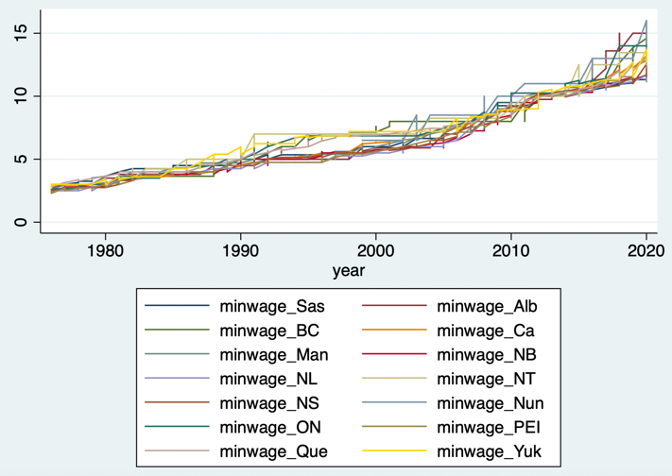

Figure 0

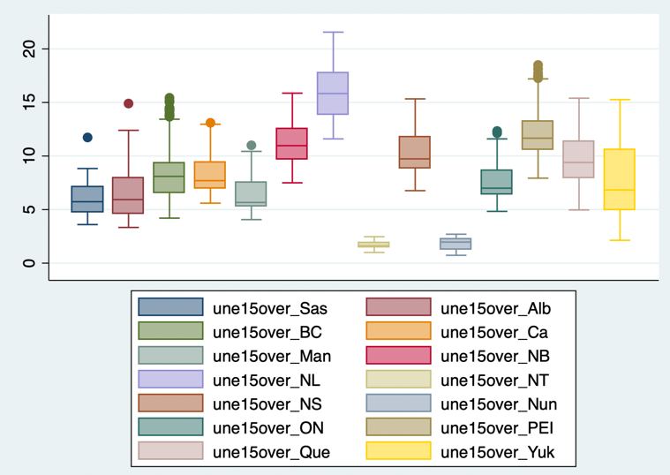

Figure 1

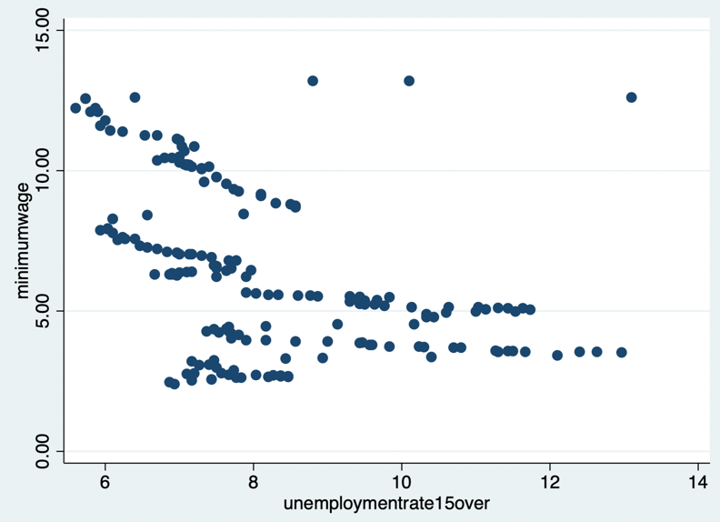

Figure 2

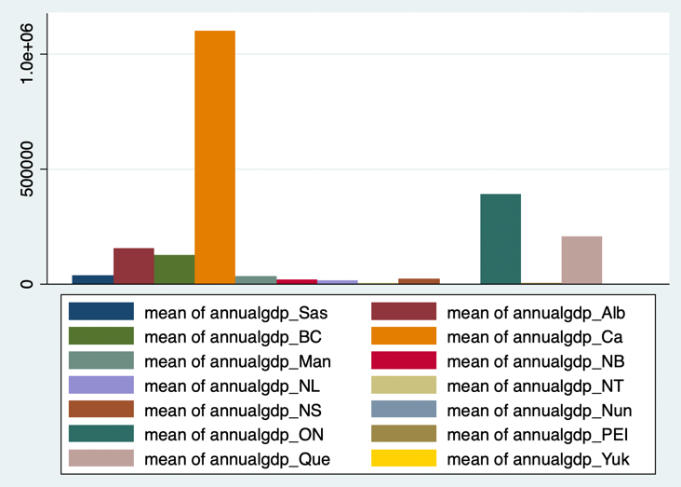

Figure 3

[1]

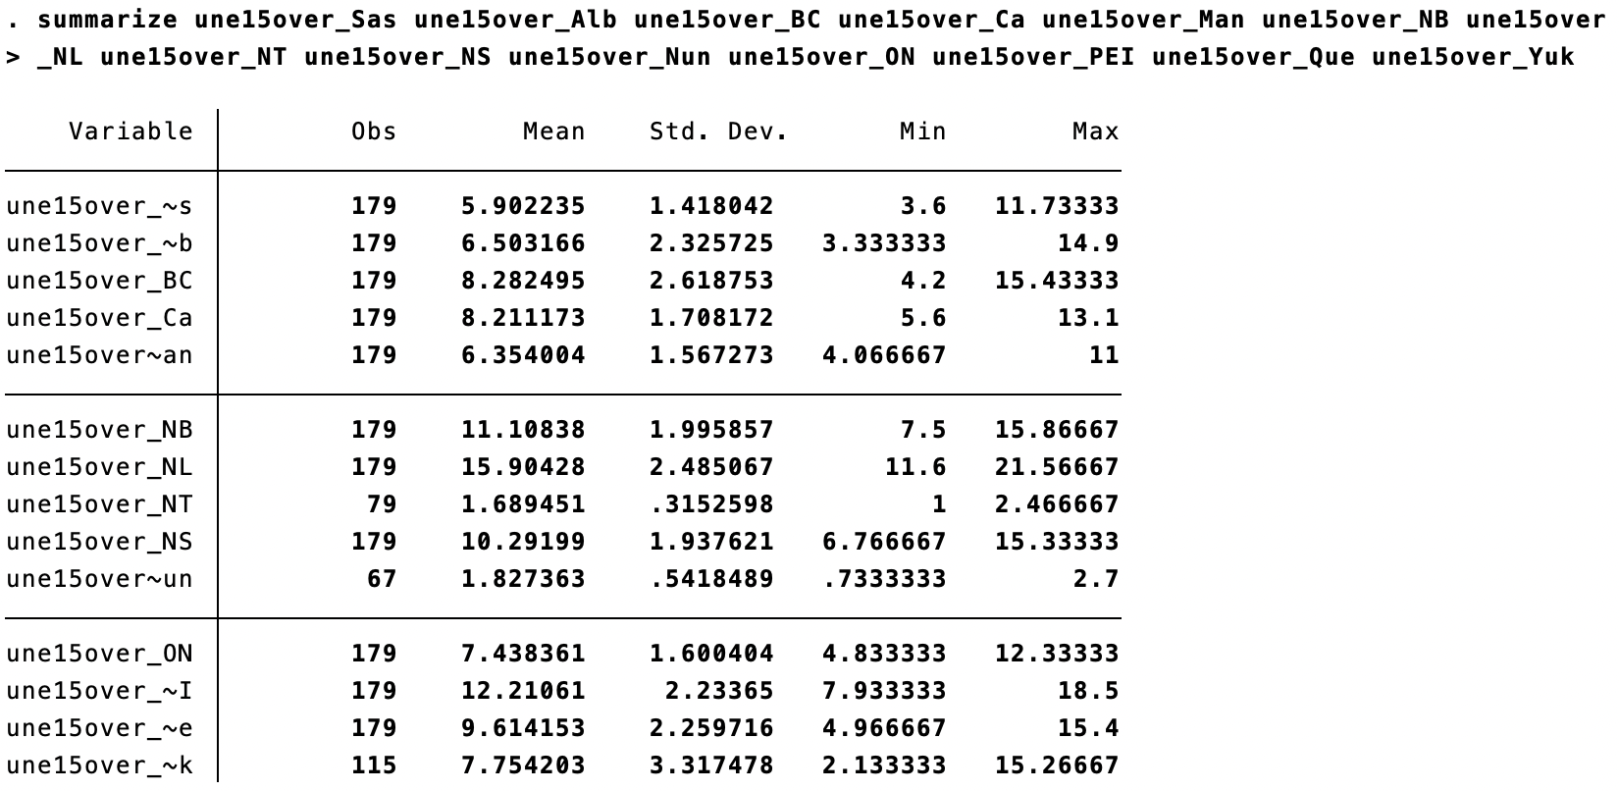

[2]: 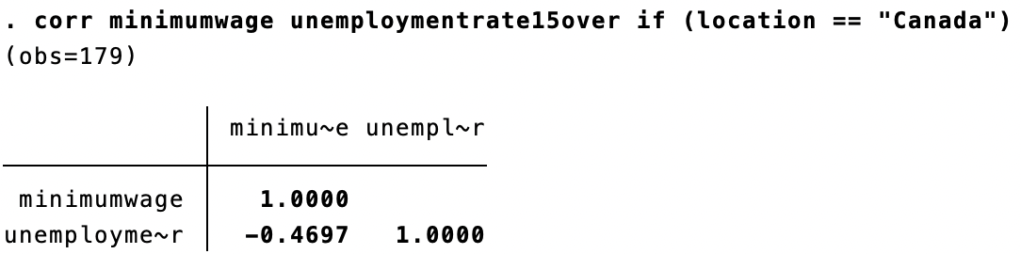

[3]

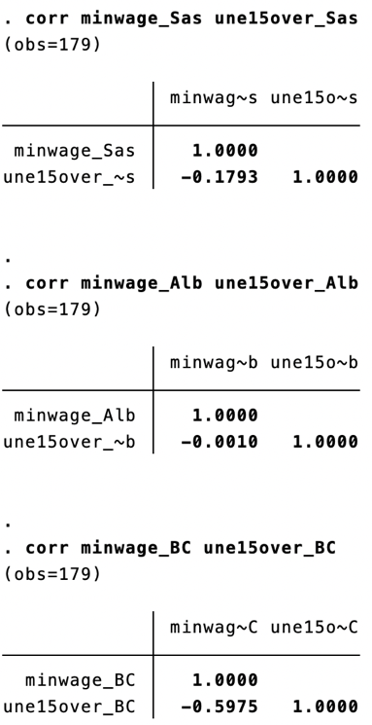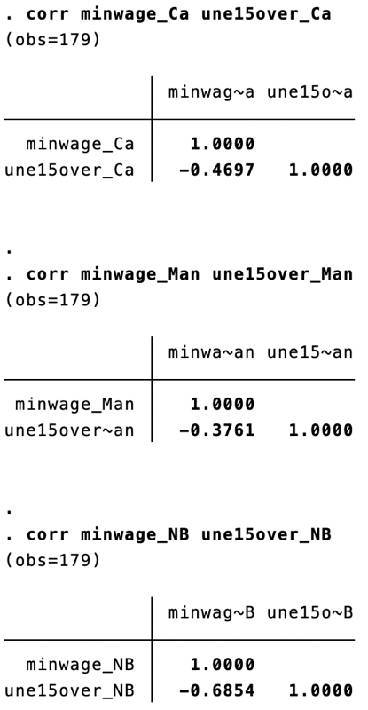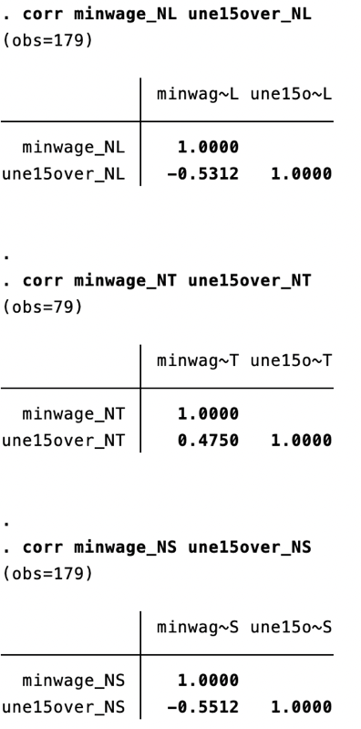

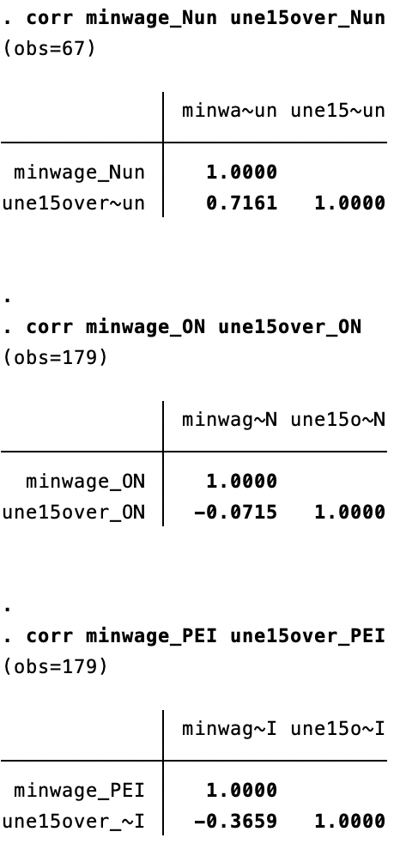 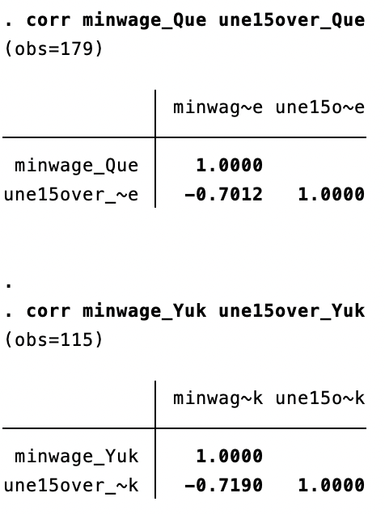

[4]

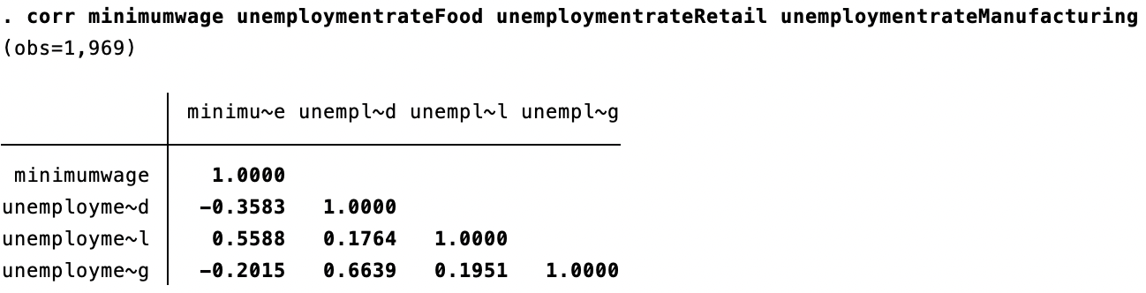

Belman, D., & Wolfson, P. J. (2014). *What does the minimum wage do?*. WE Upjohn Institute.

What harm do minimum wages do? (2020, Aug 15). *The Economist*. <https://www.economist.com/schools-brief/2020/08/15/what-harm-do-minimum-wages-do>

Immigration, R. and C. C. (2009, Sep 1). *Discover canada—Canada’s regions*. <https://www.canada.ca/en/immigration-refugees-citizenship/corporate/publications-manuals/discover-canada/read-online/canadas-regions.html>

New Brunswick Minimum Wage Report May 2021 (2021). *NBjobs.ca.*

<https://www.nbjobs.ca/sites/default/files/2021-05-11-LMI-MW-Report-EN_0.pdf> (pp. 11)

Yalnizyan, A. (2017, Jun 3). Why a $15 minimum wage is good for business. *Macleans.Ca*. <https://www.macleans.ca/economy/economicanalysis/why-a-15-minimum-wage-is-good-for-business/>